Oops project

### Library management system

Our project is mainly based on monitoring the basic activities of a Library Management System like:

1.Take a book

2.Return a book

3.Availability of books

In this project a total of 10 individual students can access the Library Management System.

All the 10 users will be having their own user-ids and passwords.

The students will be allowed to access the functions of the Library Management System if and only if

The user-id and password are authenticated.

Once they are authenticated.A student shall have the access to the following functions

1.TAKE A BOOK:

In this specific function, the student will be asked to enter the names of the bookthat he wishes to take and that respective book will be given to the student based on the availabilityof the book. 15 days from the date at which the book was taken,a date of return will be fixed and willbe shown to the user.

2.RETURN A BOOK:

Using this specific function. The student can return a book which he/she had already taken. Once the book is returned,the date of return will be checked with that of the Actual date onwhich the book has to be returned. If the date of return exceeds to that of the actual date of return,then based on the number of days exceeded, a penalty will be imposed on that student (THE PENALITYIS 1 RUPEE PER A DAY). In the other case,the book will be taken and the list of the books willbe updated.

3.AVAILABILITY OF BOOKS:

This specific function monitors on the availability of all the books that are inthe library. Based on the functions. TAKE A BOOK and RETURN A BOOK. The list of the number of bookswill be updated.

Once a student is done choosing one of the options,that specific function will be performed and the student will be asked whether he would like to continue or not at the end. If the user types"yes".The loop gets repeated and the user-id and password will be asked again. If the user types"no"...The loop gets terminated (i.e; The Project Ends).

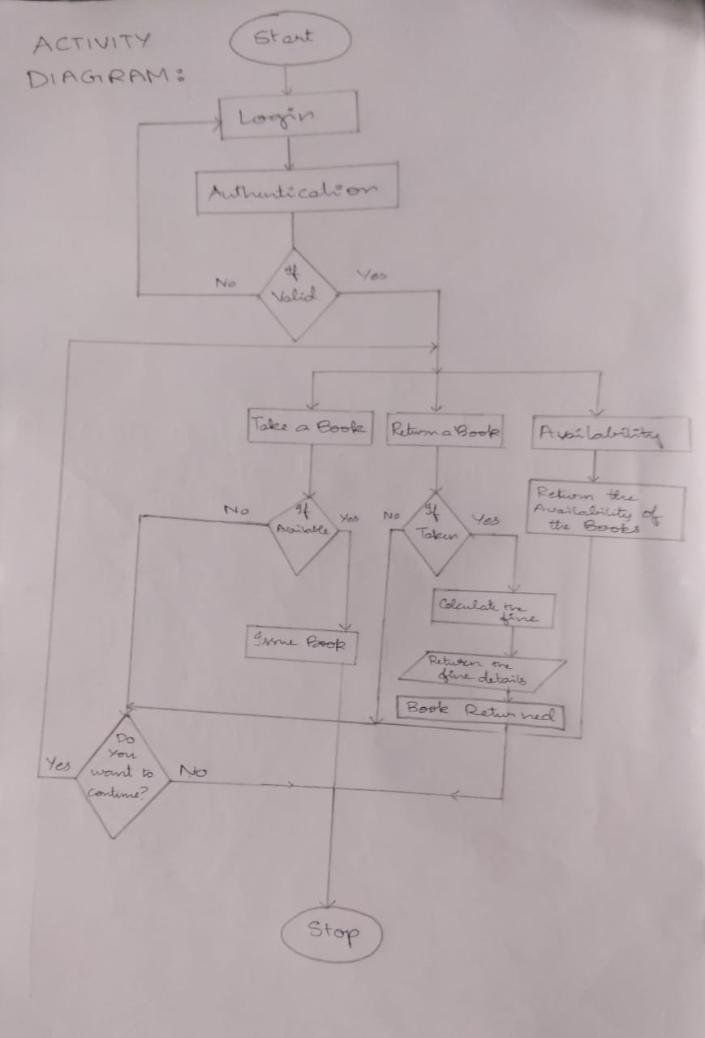

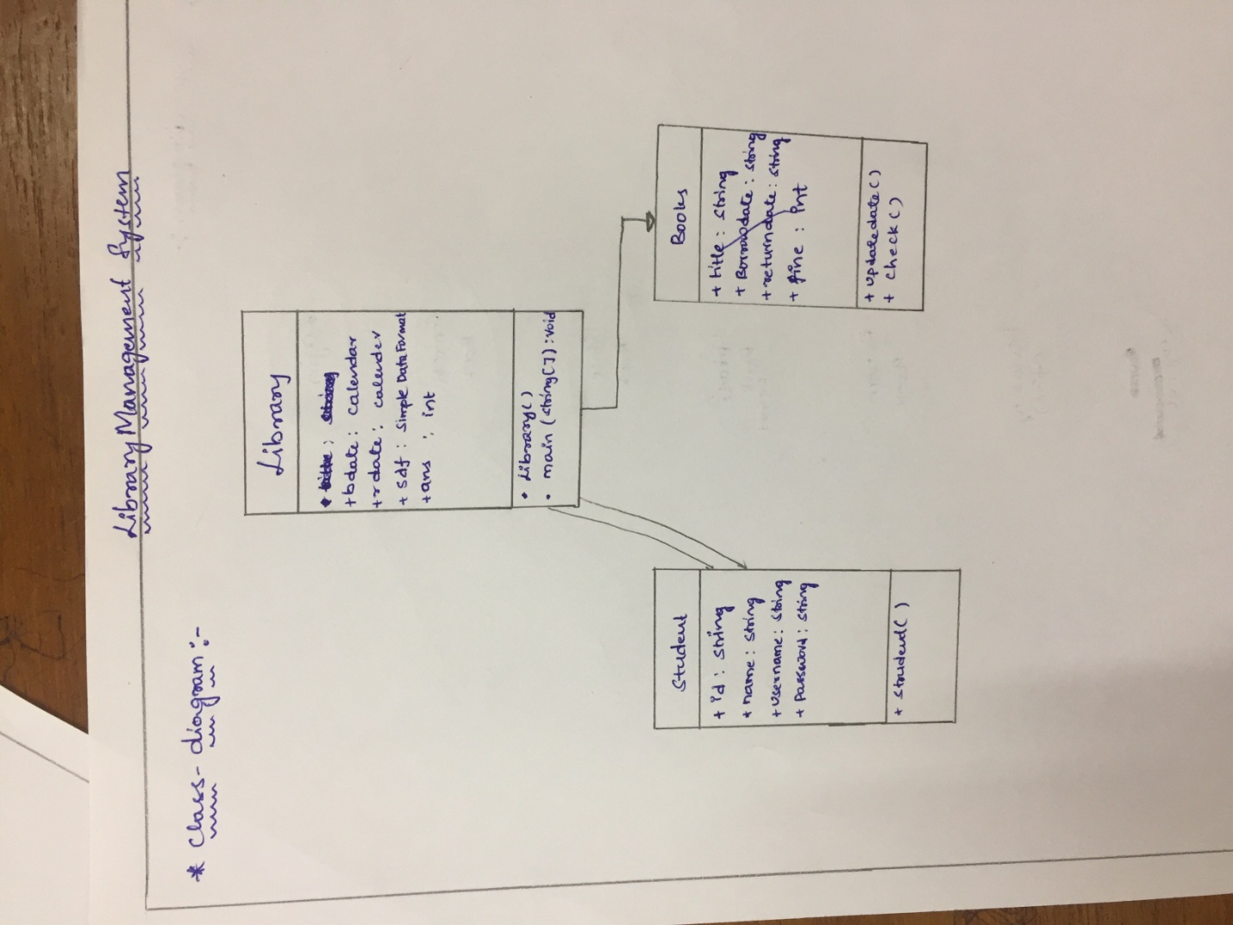

**package** librarymgmt;

**import** java.util.Scanner;

**import** java.util.Calendar;

**import** java.util.GregorianCalendar;

**import** java.text.SimpleDateFormat;

**class** Student{

String id;

String title;

Calendar bdate;

Calendar rdate;

SimpleDateFormat sdf;

String borrowdate,returndate;

**int**ans;

**int**fine=0;

Student()

{

title = **null**;

sdf = **new** SimpleDateFormat("dd MMM YYYY");

bdate = **new** GregorianCalendar();

rdate = **new** GregorianCalendar();

rdate.add(Calendar.***DAY_OF_MONTH***, +15);

borrowdate = sdf.format(bdate.getTime());

returndate = sdf.format(rdate.getTime());

}

}

**class** Book{

String name;

**boolean**availability;

Book(String name){

**this**.name=name;

availability =**true**;

}

**boolean** checkAvailability(){

**return**availability;

}

String printAvailability() {

**if**(availability)

**return**"yes";

**else**

**return**"no";

}

}

**publicclass** library **extends** Student{

**publicstaticvoid** main(String[] args) {// **TODO** Auto-generated method stub

Scanner in=**new** Scanner(System.***in***);

Student student=**new** Student();

Book[] b = **new** Book[5];

b[0]=**new** Book("harry_potter");

b[1]=**new** Book("divergent");

b[2]=**new** Book("twilight");

b[3]=**new** Book("percy_jackson");

b[4]=**new** Book("secret_series");

String users[] = {"user1","user2","user3","user4","user5","user6"};

String passes[] = {"pass1","pass2","pass3","pass4","pass5","pass6"};

**boolean**access = **true**;

**while**(**true**)

{

System.***out***.print("Enter your username : ");

student.id=in.next();

System.***out***.print("Enter your password : ");

String pass = in.next();

access=*check*(users,passes,student.id,pass);

**while**(!access) {

System.***out***.println("Invalid Password! Try again!");

System.***out***.print("Enter your username : ");

student.id=in.next();

System.***out***.print("Enter your password : ");

pass = in.next();

access=*check*(users,passes,student.id,pass);

}

**while**(access)

{

System.***out***.println("Welcome");

System.***out***.println("1. Take a book");

System.***out***.println("2. Return a book");

System.***out***.println("3. List of books");

System.***out***.println("Enter your choice : ");

student.ans=in.nextInt();

**if**(student.ans==1)

{

System.***out***.println("Enter the name of the book : ");

student.title=in.next();

**if**(*check_book*(b,student.title))

{

**if**(b[*book_index*(b,student.title)].checkAvailability())

{

System.***out***.println("Date of borrowing: "+ student.borrowdate);

System.***out***.println("Date of returning: "+ student.returndate);

b[*book_index*(b,student.title)].availability=**false**;

}

**else**

{

System.***out***.println("This book is not available");

}

}

**else**

{

System.***out***.println("This book is not available");

}

}

**elseif**(student.ans==2 &&student.title!=**null**)

{

System.***out***.println("Enter the date at which you took the book ");

**int**dd,mm,yy;

System.***out***.println("Enter the date(dd): ");

dd = in.nextInt();

System.***out***.println("Enter the month(MM): ");

mm = in.nextInt();

System.***out***.println("Enter the year(YYYY): ");

yy = in.nextInt();

Calendar dateofreturn = **new** GregorianCalendar(yy,mm-1,dd);

Calendar curdate = **new** GregorianCalendar();

dateofreturn.add(Calendar.***DAY_OF_MONTH***, +15);

SimpleDateFormat sdf = **new** SimpleDateFormat("dd MMM YYYY");

System.***out***.println("Official Return Date : " + sdf.format(dateofreturn.getTime()));

System.***out***.println("Actual Return Date: " + sdf.format(curdate.getTime()));

student.fine = curdate.get(Calendar.***DAY_OF_MONTH***) - dateofreturn.get(Calendar.***DAY_OF_MONTH***);

student.fine += (curdate.get(Calendar.***MONTH***) - dateofreturn.get(Calendar.***MONTH***))*30;

student.fine += (curdate.get(Calendar.***YEAR***) - dateofreturn.get(Calendar.***YEAR***))*365;

**if**(student.fine<0)

student.fine = 0;

System.***out***.println("You have to pay a fine of: Rs. " + student.fine);

**for**(**int**i=0 ; i<5 ; ++i)

**if**(b[i].name.compareTo(student.title)==0)

b[i].availability = **true**;

student.title = **null**;

}

**elseif**(student.ans==2 &&student.title==**null**)

System.***out***.println("Borrow a book first");

**elseif**(student.ans==3) {

**for**(**int**i=0;i<5;i++) {

System.***out***.println("Name : " + b[i].name+"\nAvailablity : "+b[i].printAvailability());

}

}

String choose;

System.***out***.println("Do you want to continue yes or no?");

choose=in.next();

**if**(choose.compareTo("no")==0)

**break**;

}

}

}

**publicstaticboolean** check(String[] u,String[] p,String user,String pass) {

**for**(**int**i =0;i<u.length;i++)

**if**(user.compareTo(u[i])==0)

**if**(pass.compareTo(p[i])==0)

**returntrue**;

**returnfalse**;

}

**publicstaticboolean** check_book(Book u[],String x)

{

**for**(**int**i =0;i<u.length;i++)

**if**(x.compareTo(u[i].name)==0)

**returntrue**;

**returnfalse**;

}

**publicstaticint** book_index(Book u[],String x)

{

**for**(**int**i =0;i<u.length;i++)

**if**(x.compareTo(u[i].name)==0)

**return**i;

**return** -1;

}

}